

DTSC-625: Data Engineering

Using Lambda to Convert a CSV to a Parquet File

Adapted from Eagar, Data Engineering with AWS, 2nd ed.

In this lab we’re going to configure an S3 bucket to automatically trigger a Lambda function whenever a new file is written to the bucket.

In the Lambda function, we’ll use an open-source Python library called AWS SDK for pandas.

We’ll use the AWS SDK for pandas library to convert a CSV file into Parquet format and then update AWS Glue Data Catalog. The Lambda function will create a glue database and a glue table holding the contents of the Parquet file.

Architecture



Lambda and state machine assigned appropriate IAM permissions

Lambda logs events in CloudWatch


S3 stores Parquet file



Lambda converts to Parquet, stores in S3 bucket and creates table in Glue
S3 stores parquet and triggers new Lambda function
User uploads data as CSV


Parquet file inserted into Glue Data Catalog

S3 stores Athena query results as CSV
Athena queries table and outputs results

Step 1. Create a Lambda layer containing the AWS SDK for pandas library
Lambda layers allow your Lambda function to bring in additional code, packaged as a zip file. In
In our use case, the Lambda layer is going to contain the AWS SDK for pandas Python library, which we can then attach to any Lambda function where we want to use the library.

To create a Lambda layer, do the following:

- Access the 3.13.0 version of the AWS SDK for pandas library provided on GitHub at https://github.com/aws/aws-sdk-pandas/releases/tag/3.13.0. There are two options for awswrangler 3.13.0 and Python 3.13. Choose the second option, highlighted below:
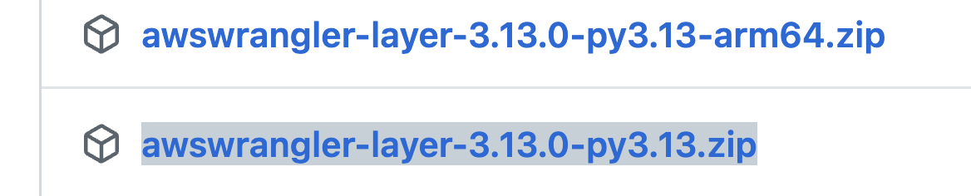

- Log in to the AWS Management Console in your account as an administrative user. Make sure that you are in the same Region that you use for other classwork.

- In the top left search bar of the AWS console, search for and select the Lambda service. If you want to save Lambda as a bookmark within your console, select the star on the right.
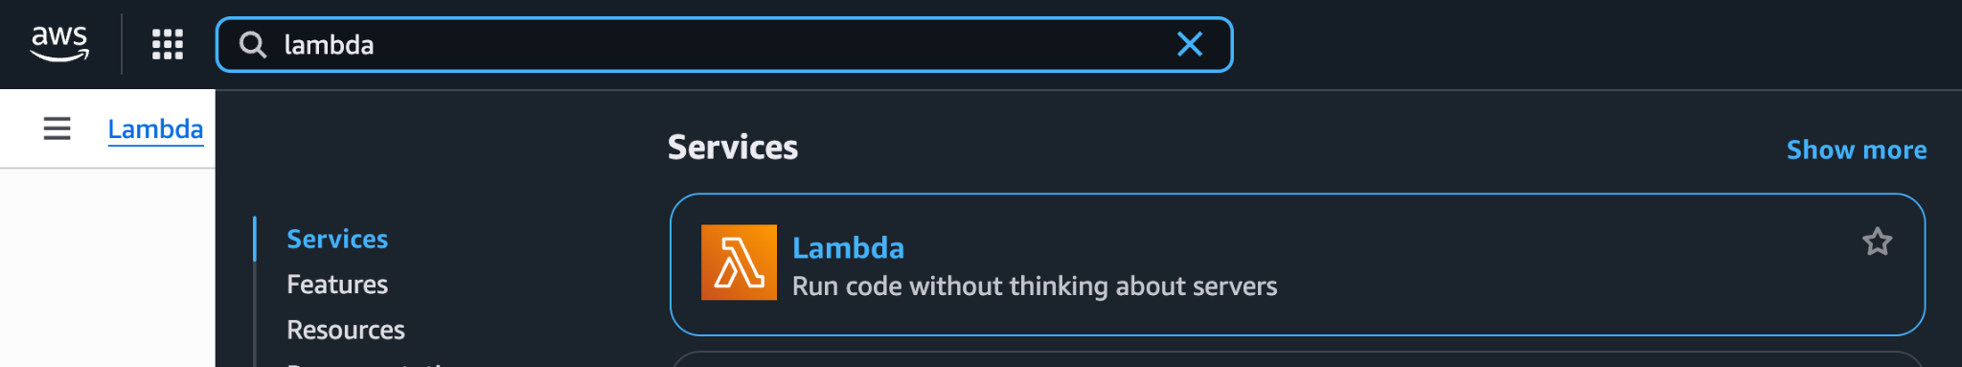

- In the left-hand menu, under Function Resources, select Layers.
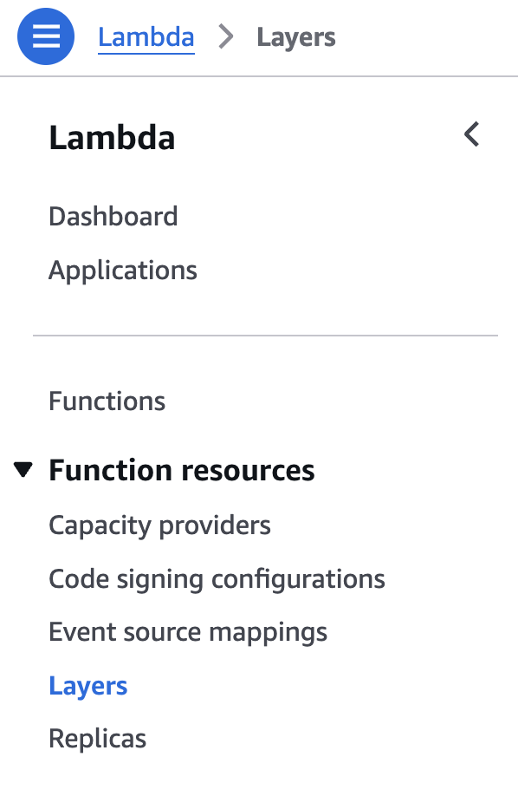

5. Click on the yellow “Create layer”. Provide a name for the layer (for example, awswrangler_python313) and an optional description, and then upload the .zip file you downloaded from GitHub. For Compatible runtimes-optional, select Python 3.13:
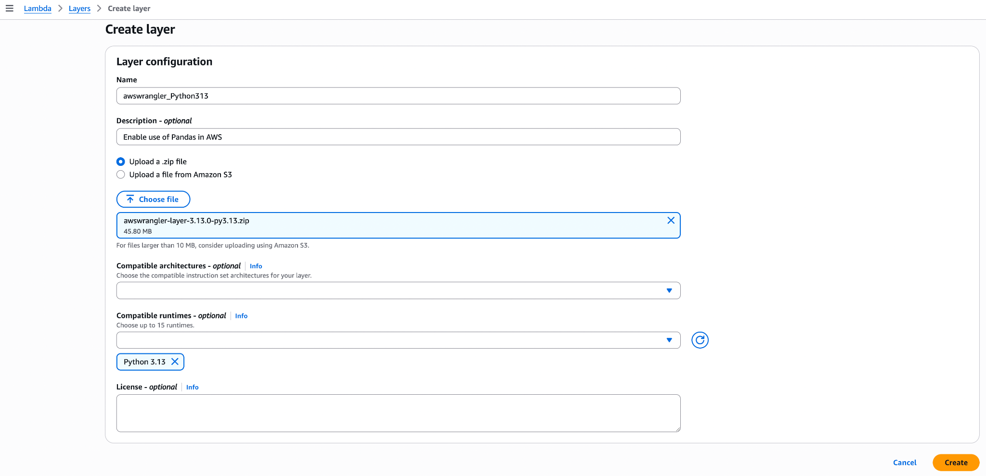
6. Click Create.

7. You should now have an awswrangler layer listed!
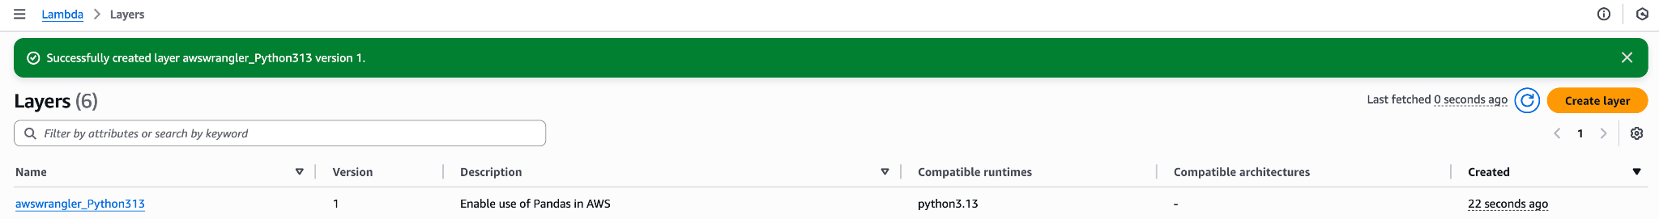

We can attach this layer to any Python 3.13 Lambda function that requires Pandas, NumPy, or the awswrangler library itself. If your Lambda code doesn't rely on any of these libraries, then attaching this layer is not necessary.

Step 2. Create an IAM policy and role for your Lambda function
In a demo video, we created a data lake with three zones: landing, clean, and curated.
In this lab, we will create a Lambda function to be triggered every time a new file is uploaded
to our landing zone S3 bucket.

The Lambda function will process the file and write out a new version of the file to a target bucket (our clean zone S3 bucket). For this to work, we need to ensure that our Lambda function has the following permissions:

- Read our source S3 bucket (for example, dtsc625-<lastname>-landing-zone).
- Write to our target S3 bucket (for example, dtsc625-<lastname>-clean-zone).
- Write logs to Amazon CloudWatch.
- Access to all Glue API actions (to enable the creation of new databases and tables).

To create a new AWS IAM role with these permissions, follow these steps:

- In the search bar at the top of the AWS console, search for and select the IAM service.
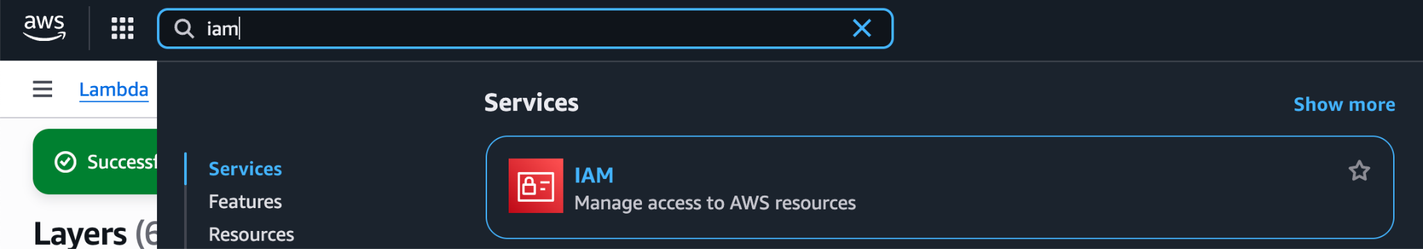

- In the left-hand menu, select Policies and then click on Create policy.
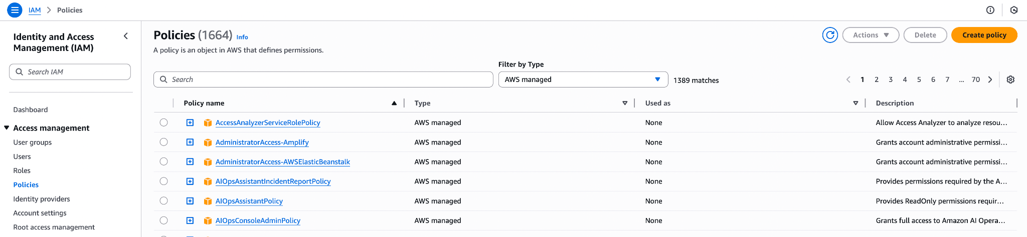

- Click on JSON to change to the JSON tab.
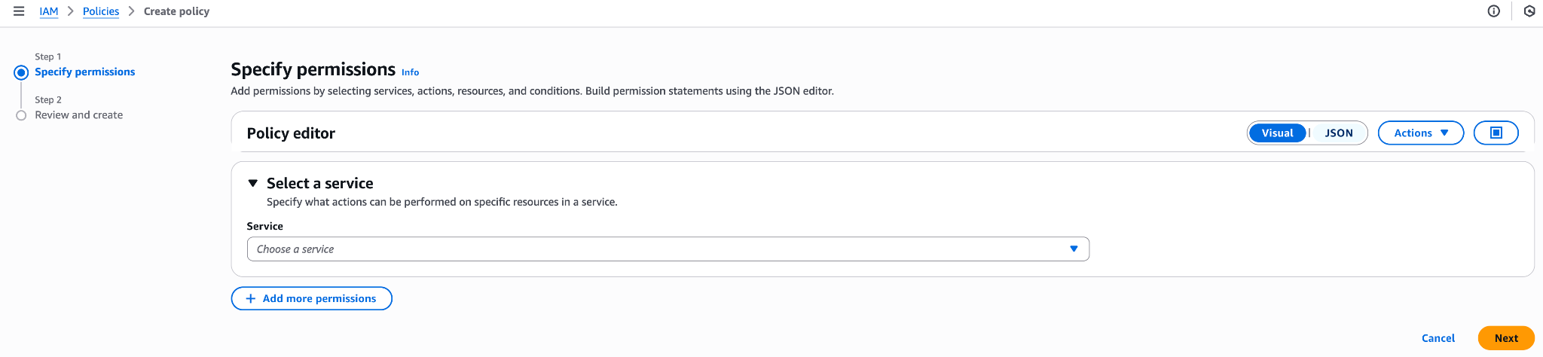

- Delete the blank JSON code provided. Be sure to delete all brackets.

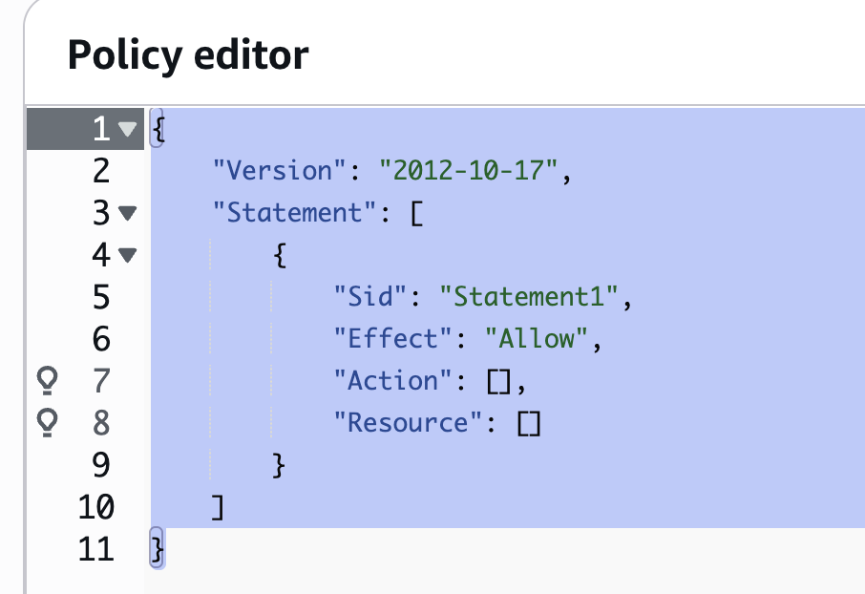
- Copy and paste the following JSON into the editor. Be sure to copy the beginning and ending brackets! I will provide comments in this Google doc to explain the importance of each block. Be sure to update the bucket name with the one you created in the demo earlier in the course.

{
"Version": "2012-10-17",
"Statement": [
{
"Effect": "Allow",
"Action": [
"logs:PutLogEvents",
"logs:CreateLogGroup",
"logs:CreateLogStream"
],
"Resource": "arn:aws:logs:*:*:*"
},
{
"Effect": "Allow",
"Action": [
"s3:*"
],
"Resource": [
"arn:aws:s3:::dtsc625-<lastname>-landing-zone/*",
"arn:aws:s3:::dtsc625-<lastname>-landing-zone",
"arn:aws:s3:::dtsc625-<lastname>-clean-zone/*",
"arn:aws:s3:::dtsc625-<lastname>-clean-zone"
]
},
{
"Effect": "Allow",
"Action": [
"glue:*"
],
"Resource": "*"
}
]
}

- Click on Next and then provide a name for the policy, such as LambdaS3GlueCloudWatchPolicy, and then click Create policy.

- To search for the policy, type a word in the name of the policy (such as cloudwatch) and filter by “customer managed” type. You should see the policy listed.
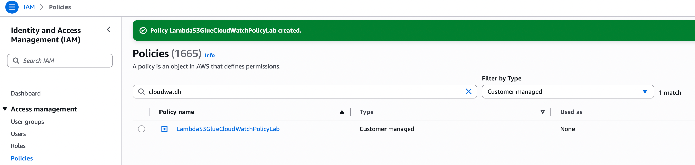

- In the left-hand menu, click on Roles.
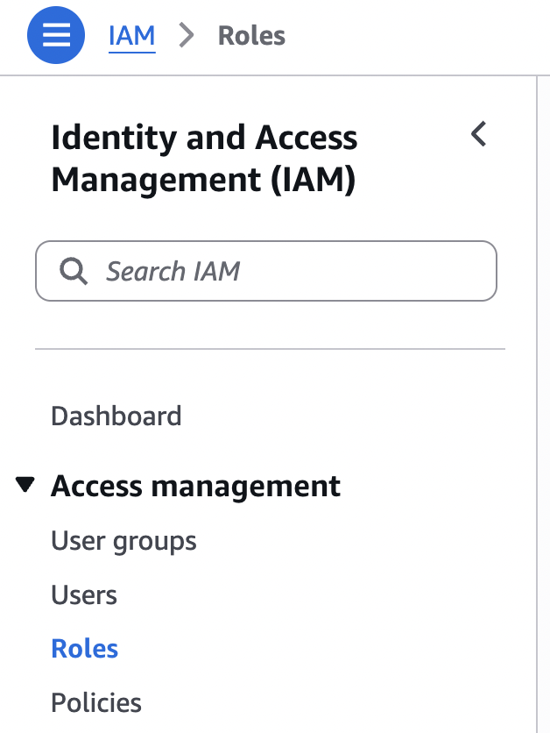
- Click on Create Role.
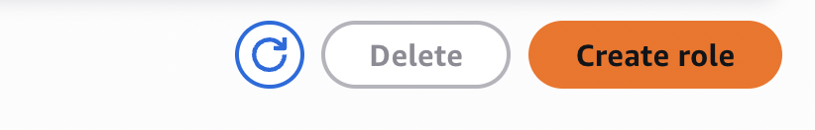
- For the trusted entity type, ensure AWS service is selected, and for the service, select Lambda and then click Next.
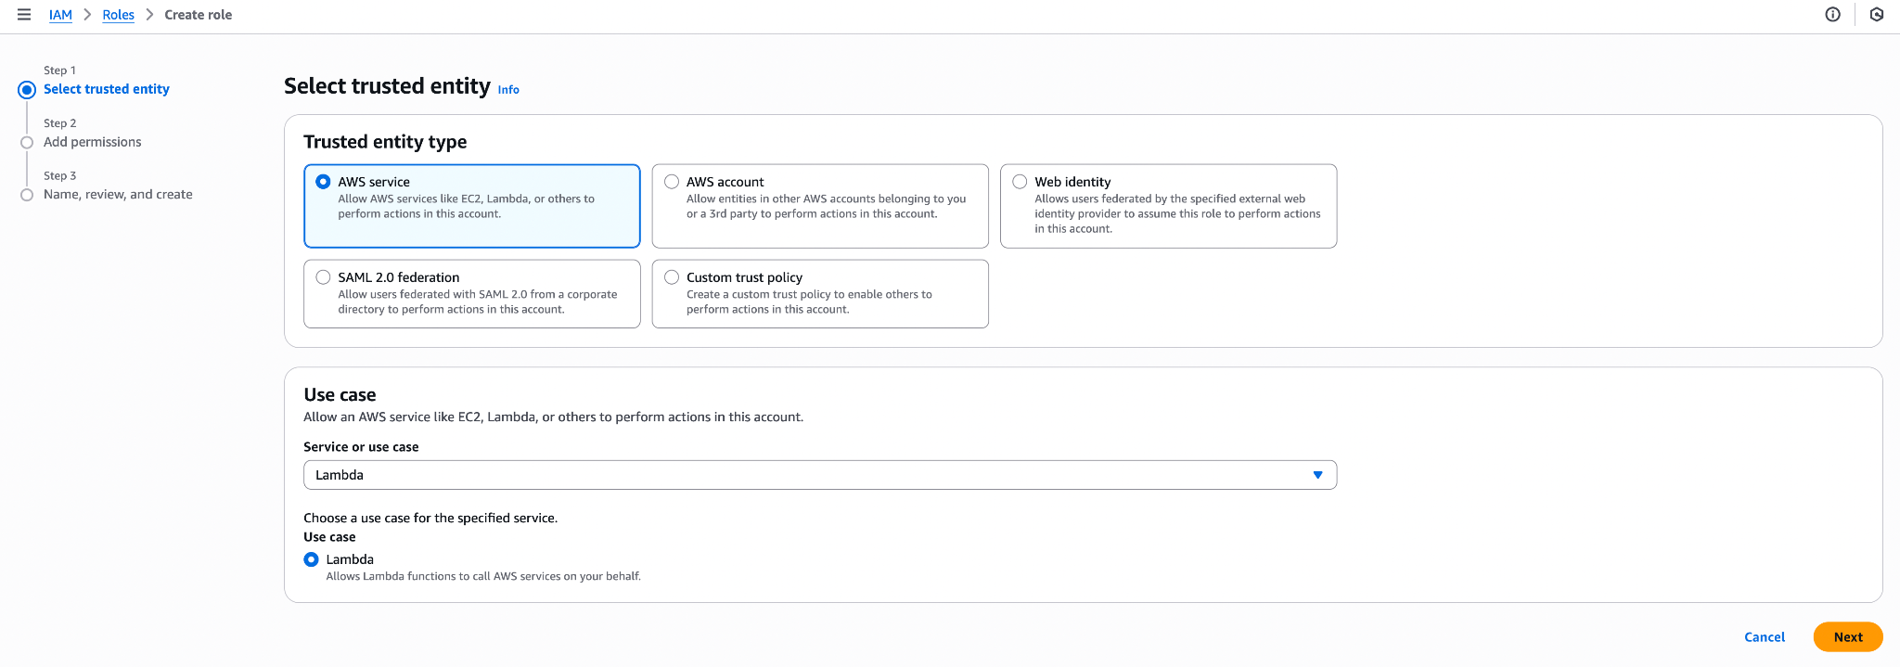
- Under Add permissions, search for and select the policy we just created (i.e., click the square tick box next to the name). Then, click Next.

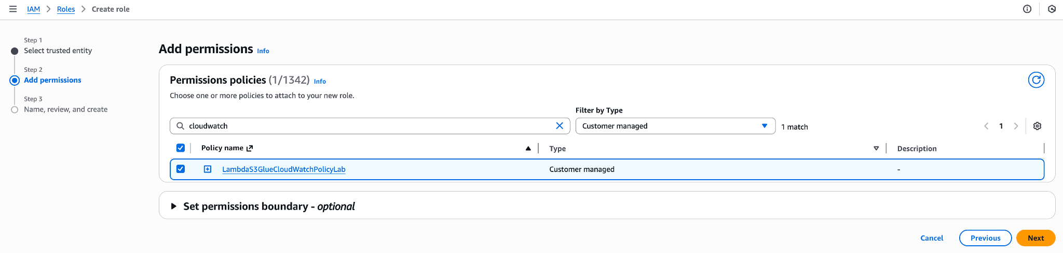

- Provide a role name, such as dtsc625LambdaRole-S3GlueCloudWatch.
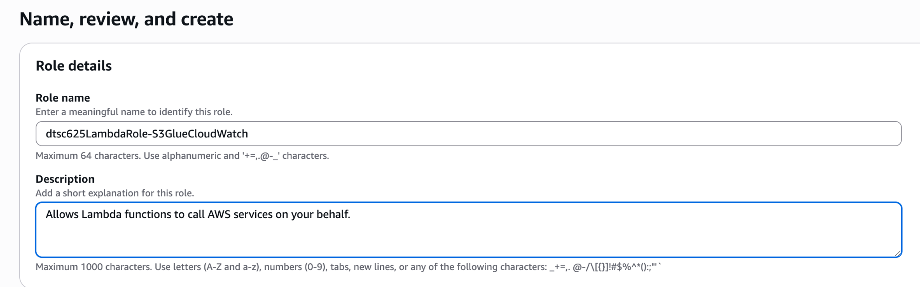

- Add tags (Key: dtsc625; value: csv-to-parquet) and click Create role.
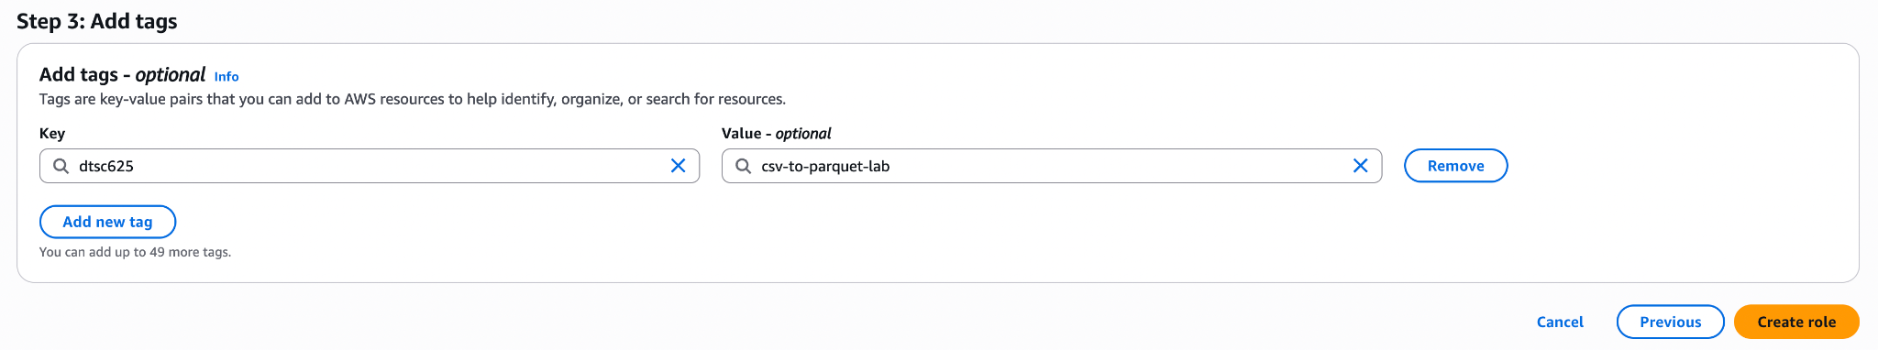

Step 3. Create a Lambda function
We are now ready to create our Lambda function! When we upload a CSV to our landing-zone bucket, the Lambda function will be triggered. The Lambda function will convert the CSV to a Parquet file, store the new file in the clean-zone bucket, and create a database with a table in it based on the data in the parquet file.

- In the AWS console, search for and select the Lambda service, and in the left-hand menu, select Functions and then click Create function. Make sure you are in the same Region as where you created your AWS buckets in the class demo. The screenshot below shows the us-east-1 Region, but your Region may differ.

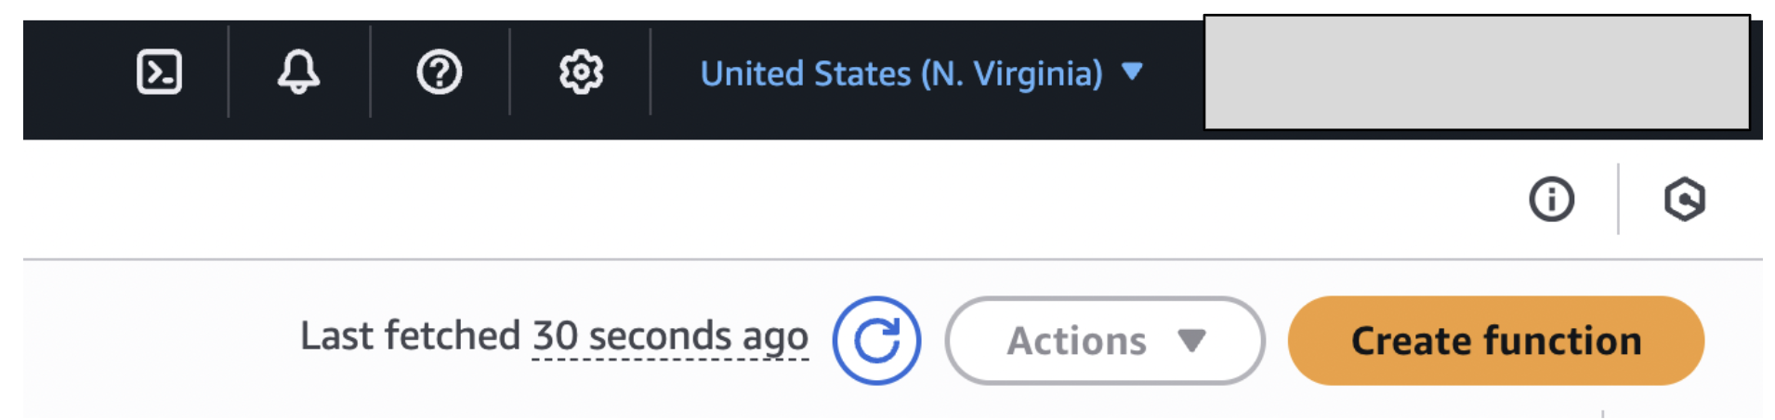

- Select Author from scratch, provide a function name (such as dtsc625-csv-to-parquet), and, under Runtime, select Python 3.13.
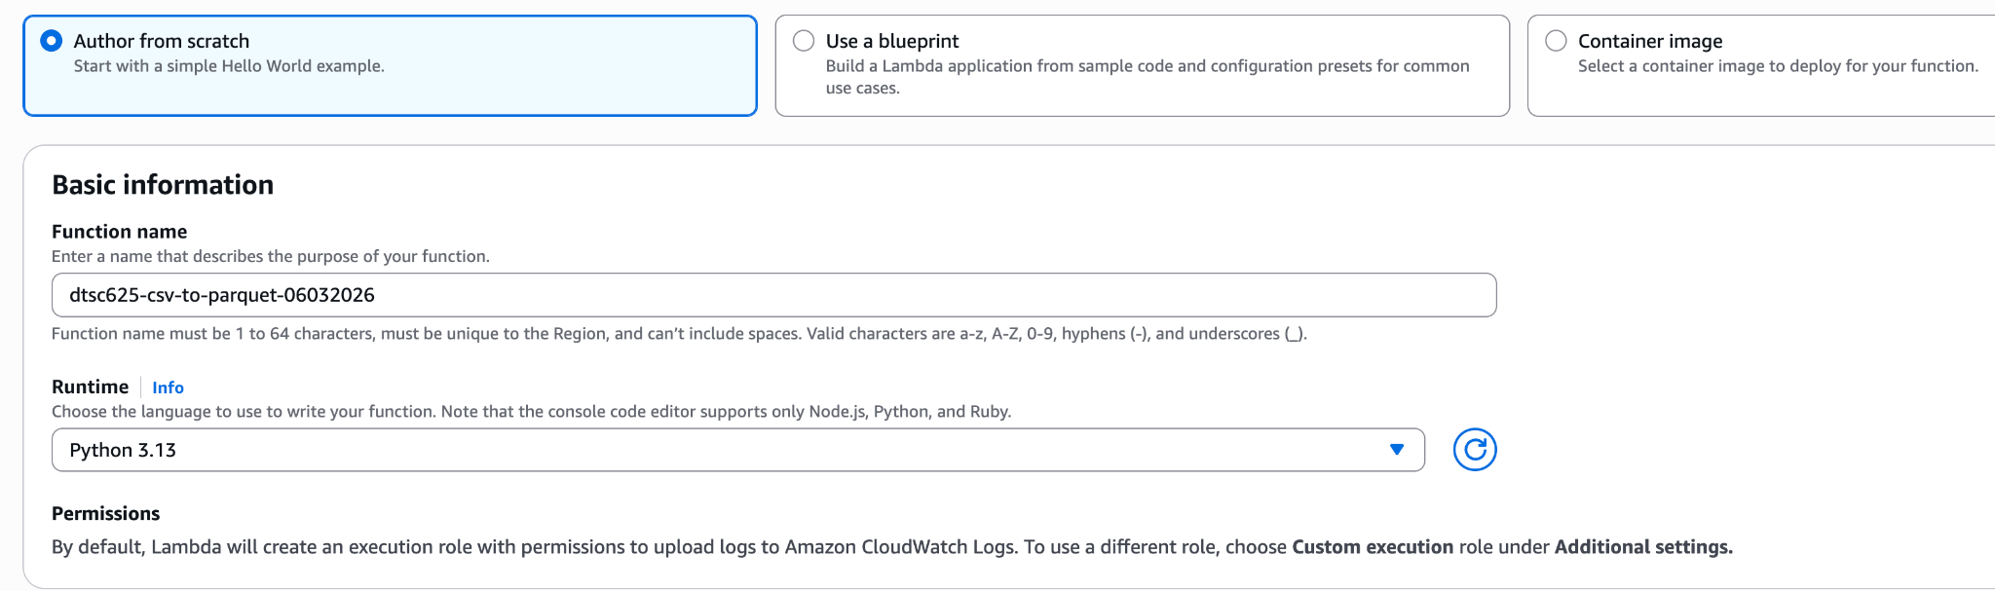
- Under Custom settings, select “Additional settings” then click the toggle button next to “Custom execution role.”
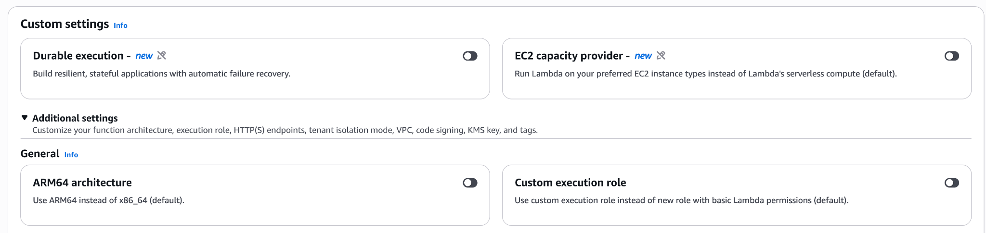

- In the side panel that opens, select the IAM role you created earlier in this lab.
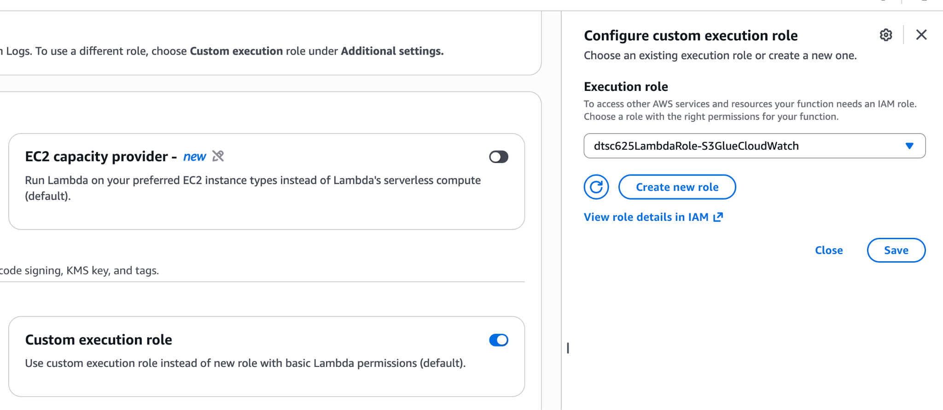

- Click Save. You should now see the role listed under Custom execution role.
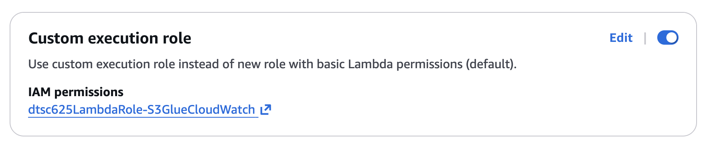

- Scroll down and find “Tags” under Security & governance.
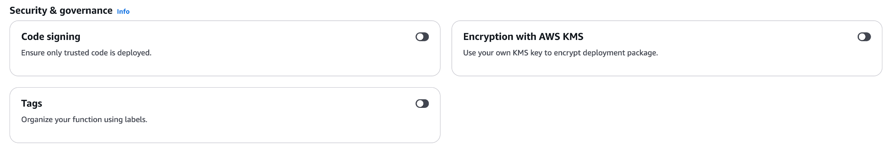
- Click the toggle button next to “Tags”, and in the “Configure tags” panel that opens, provide a key and a value. Click Save.
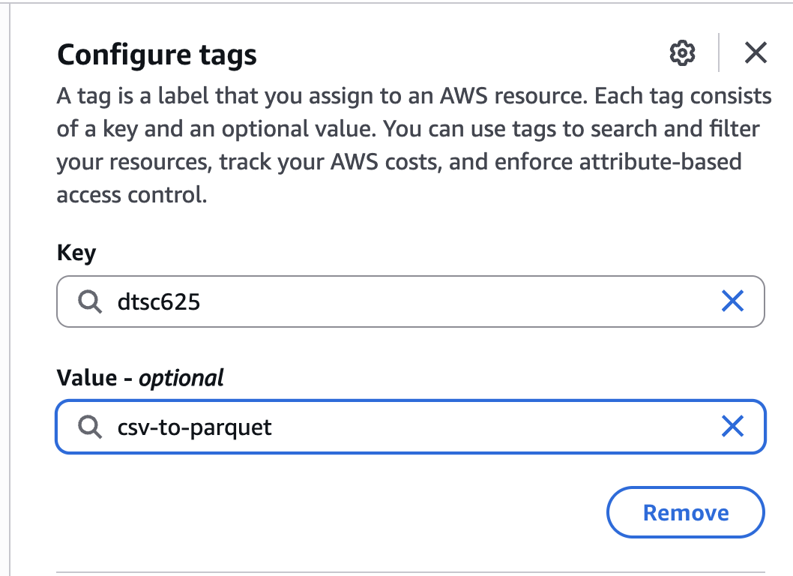

- At the bottom, select Create function.

- Click on Layers under the name of the Lambda function. This takes you to the “Layers” menu at the bottom of the page.
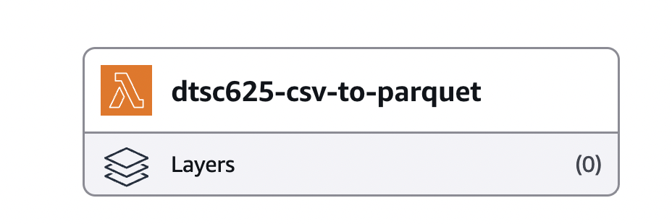

- On the right, select Add a layer.
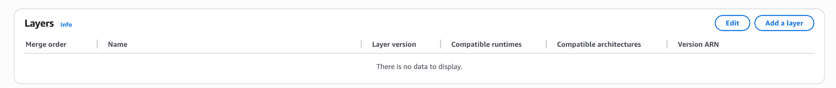

- Select Custom layers, and from the dropdown, select the awswrangler_Python313 layer you created in a previous section. Select the latest version and then click Add.
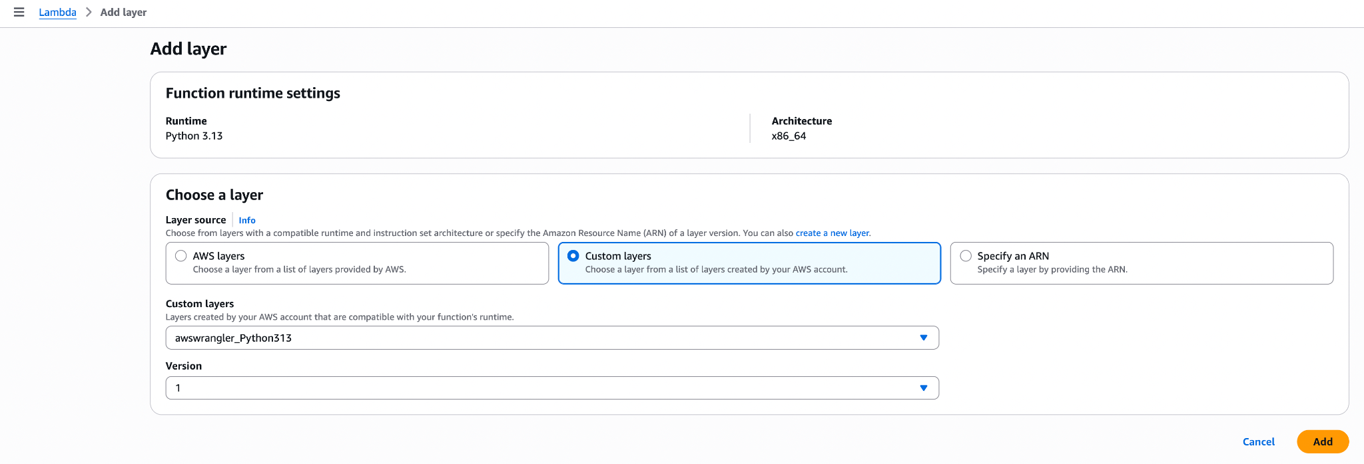

- Scroll down to the Code section in the Lambda console. Delete the existing code.
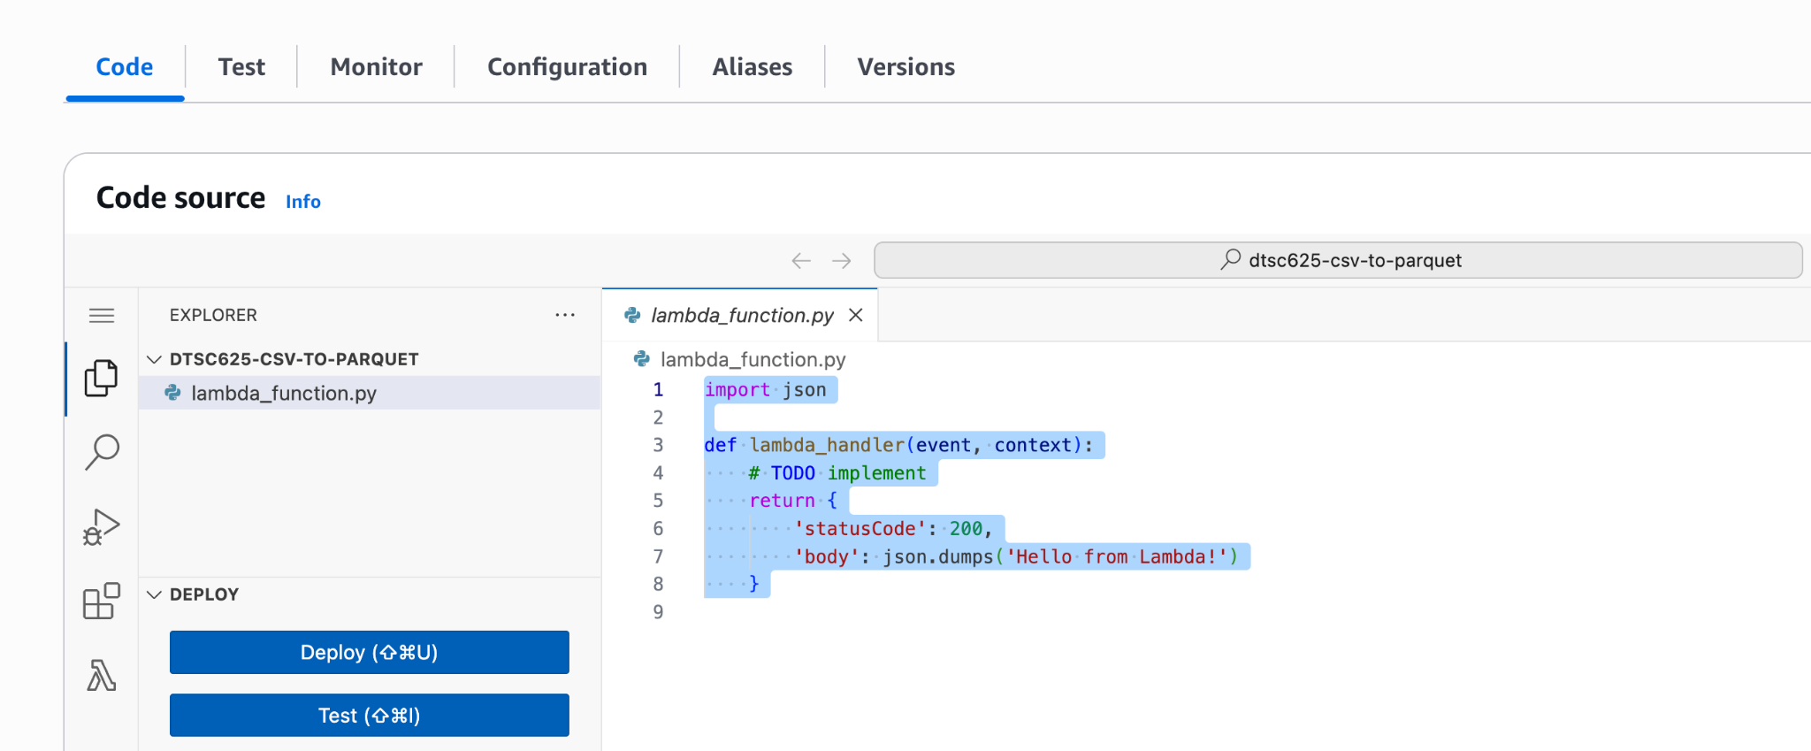

- Download the code from Brightspace and insert it here. Be sure to upload the S3 bucket name to match your clean-zone bucket name. Here is a snippet of the code:
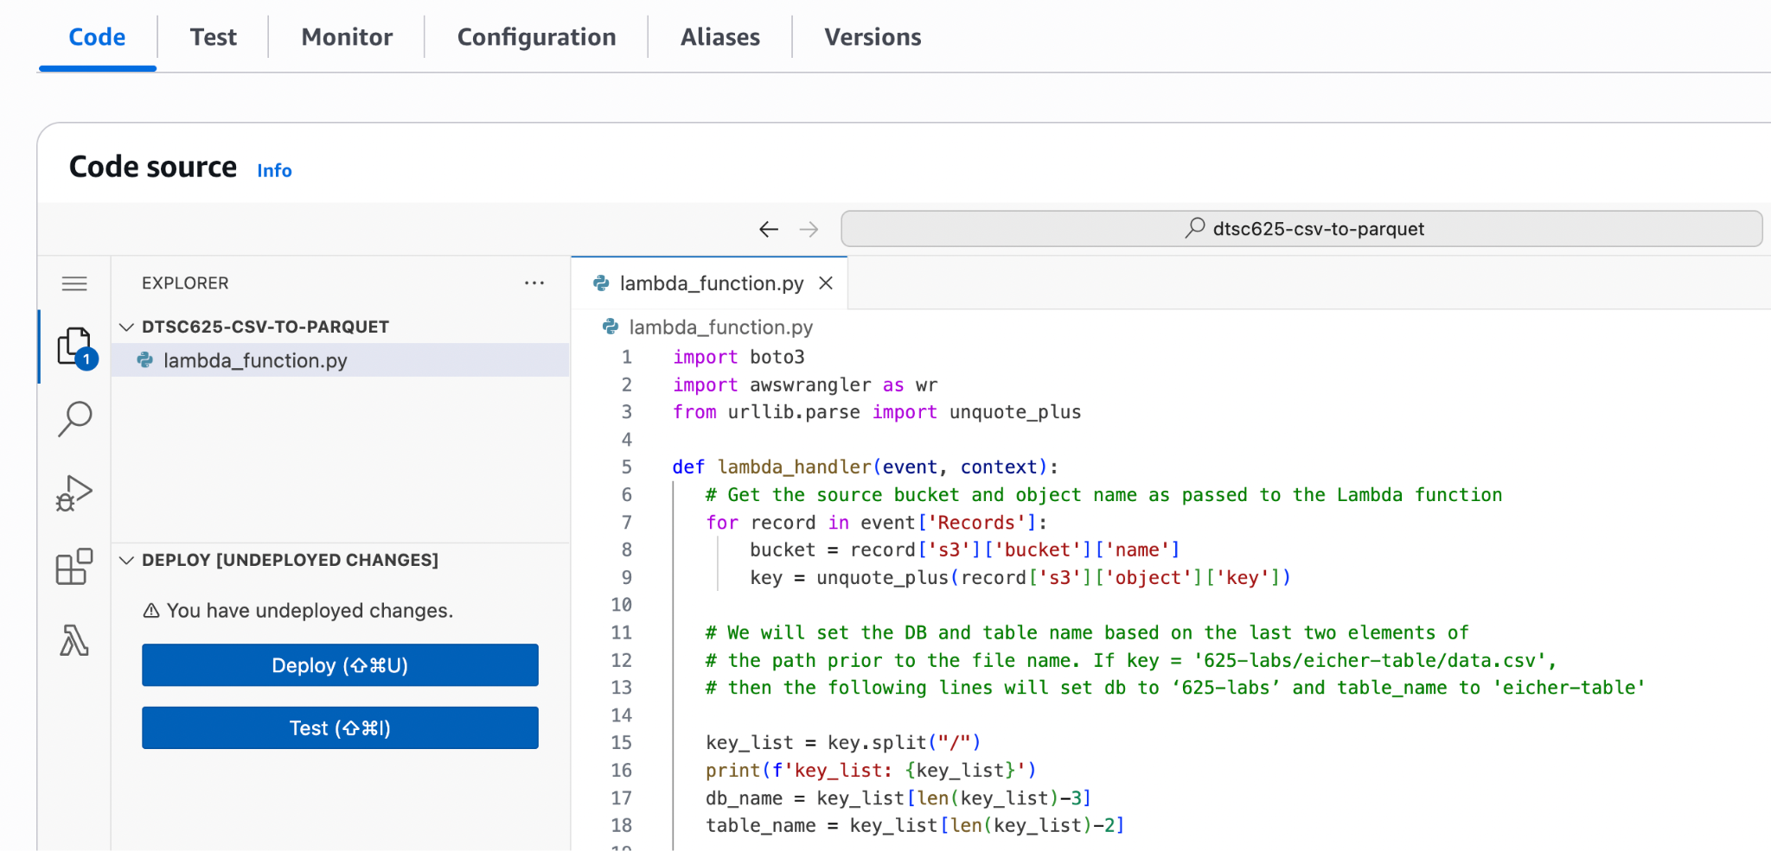

- Click on Deploy on the left side of the Code window. Notice that if you edit the code at all, you will get a message about “undeployed changes.” If you don’t deploy, any changes you make will take effect the next time the Lambda function runs.
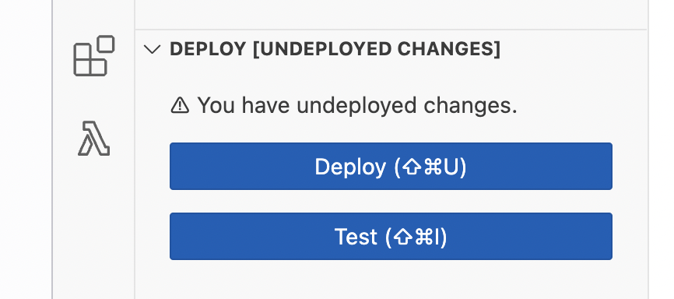

- Click on the Configuration tab (above the Code Source window), and on the left-hand side, click on General configuration and click the Edit button on the right.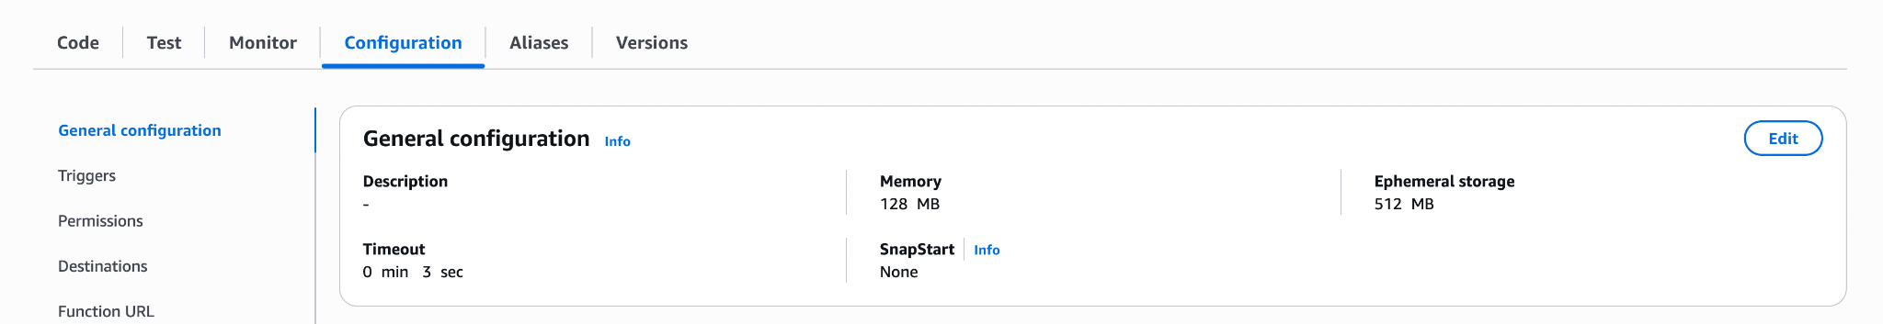

- Modify the Memory to be 256 MB and the Timeout to be 1 minute. The default Memory may not work for Python 3.13 and the default timeout of 3 seconds is likely to be too low to convert some files from CSV into Parquet format. Select Save.
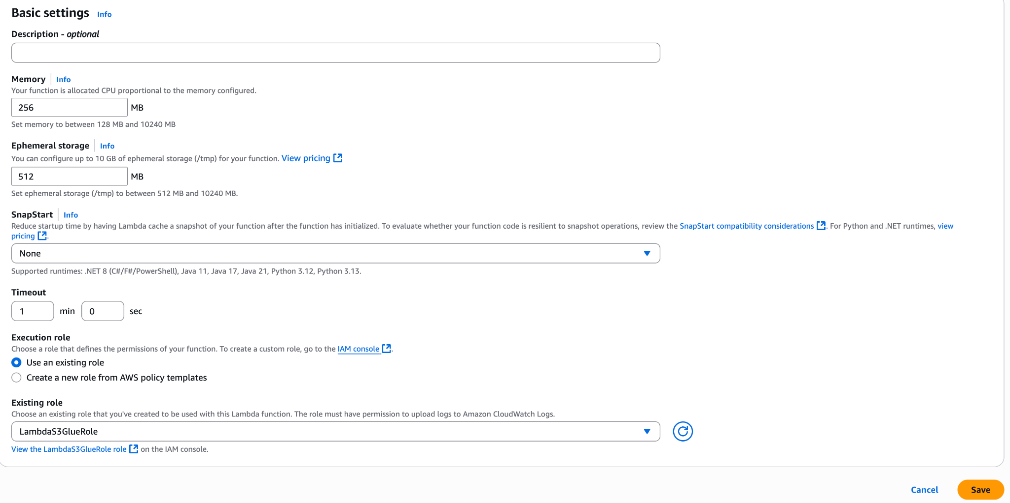

Step 4. Configure our Lambda function to be triggered by an S3 upload
Our final task is to configure the Lambda function so that whenever a CSV file is uploaded to our landing zone bucket, the Lambda function runs and converts the file into Parquet format and saves a table in a Glue database.

1. In the Function Overview box of our Lambda function, click on Add trigger.
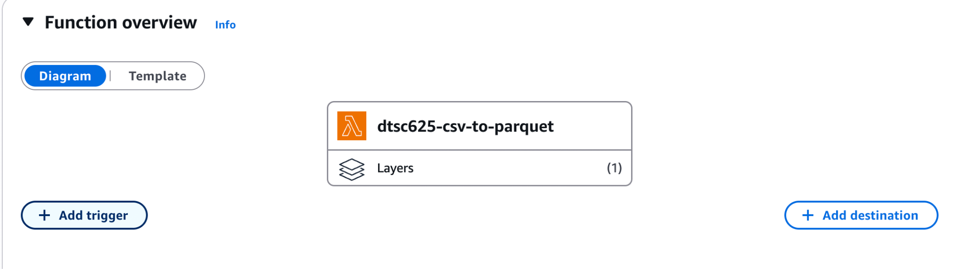

2. For Trigger configuration, type S3 and select the S3 service.
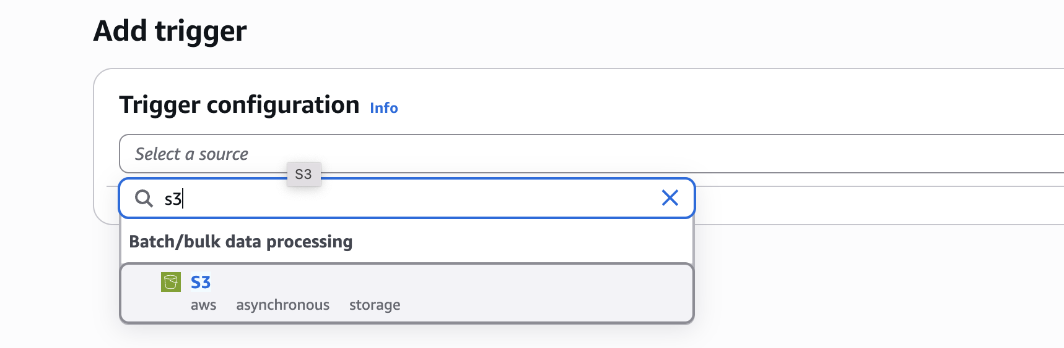
3. For Bucket, select your landing zone bucket. In the screenshot below, I named my bucket 000landingzone. We want our rule to trigger whenever a new file is created in this bucket, no matter what method is used to create it (Put, Post, or Copy), so select All object create events from the list. For suffix, enter .csv. This will configure the trigger to only run the Lambda function
when a file with a .csv extension is uploaded to our landing zone bucket.
4. Acknowledge the warning about Recursive invocation, which can crop up if you set up a trigger on a specific bucket to run a Lambda function and then you get your Lambda function to create a new file in that same bucket and path. This is a good time to double-check and make sure that you are configuring this trigger in the LANDING ZONE bucket and not the target CLEAN ZONE bucket that our Lambda function will write to.

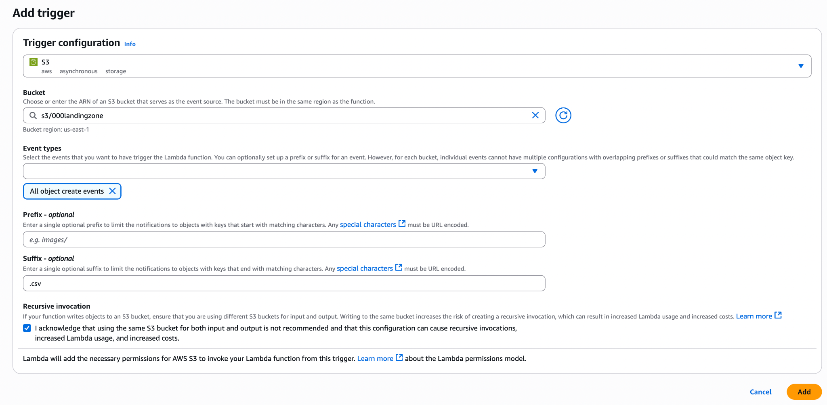

5. Click Add to create the trigger. You should now see an S3 bucket triggering the Lambda function.
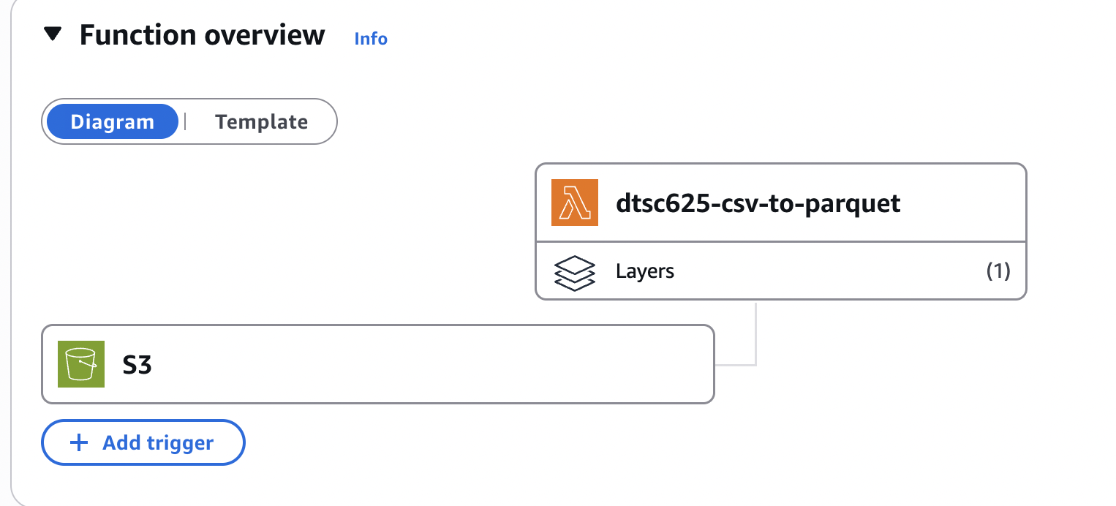

Step 5. Test our Lambda function
1. Download the sc_ap2021.csv file from Brightspace. We will upload this file to our S3 landing-zone bucket to test the trigger the Lambda function.

2. Navigate to the Amazon S3 console (https://s3.console.aws.amazon.com/s3) and click
on the landing-zone bucket that you previously created. Then click on Create folder and provide a folder name of dtsc625-labs. The top-level folder we create here is going to be used as the name of the database that will be created in Glue Data Catalog to store our new table.

3. Navigate into the dtsc625-labs folder, and create a second-level folder (this will be used
as the name of the table that gets created in Glue Data Catalog). Name the second-level
folder sc_ap2021.

4. Navigate into the sc_ap2021 folder, click on Upload, and then upload the ap2021-schools.csv file. The file should be uploaded into the landing-zone bucket in the folder path /dtsc625-labs/sc_ap2021.

5. If everything has been configured correctly, your Lambda function will have been triggered
and will have written out a Parquet-formatted file to your target S3 bucket and created a Glue database and table.

6. Access the Glue service in the AWS Management Console to ensure that a new database and table have been created in the data catalog.

7. Run the following command in CloudShell to ensure that a Parquet file has been written to
your target bucket. Make sure to replace the bucket name and folder names to match with your names. The result of this command should display the Parquet file that was created by the Lambda function.

aws s3 ls s3://dtsc625-<lastname>-clean-zone/dtsc625-labs/sc_ap2021

8. Check that the parquet file exists in the clean-zone bucket (in the sub-folders).

9. Note: we will use the buckets and lambda function in future classwork, so do not delete them.

Template
- Complete the template provided on Brightspace, populating it with the requested screenshots.
- Make a copy of the assignment template (File > Make a copy) to fill in your answers and add screenshots. Download your completed template as a PDF Document to submit here.

